----------

URL : http://demo.automationtesting.in/Alerts.html

NOTE: Click button to display an alert box and click ok button

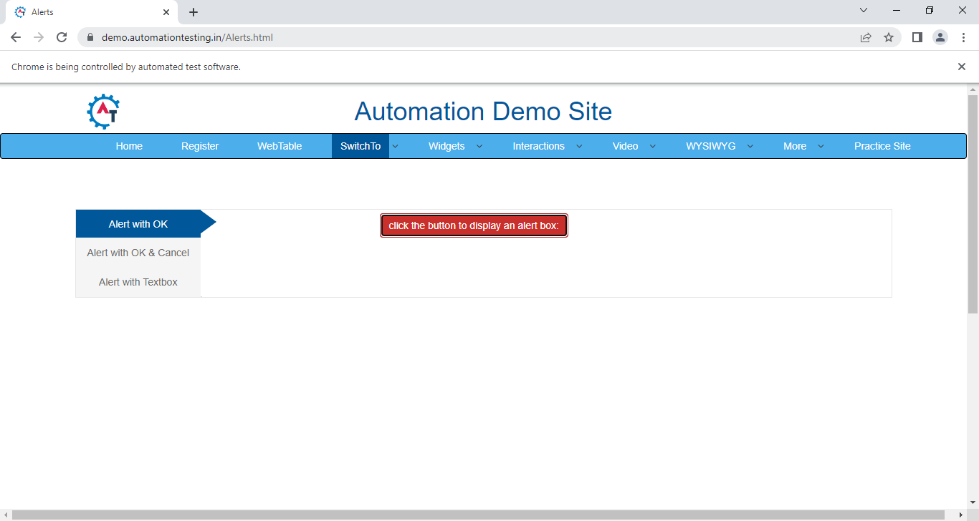

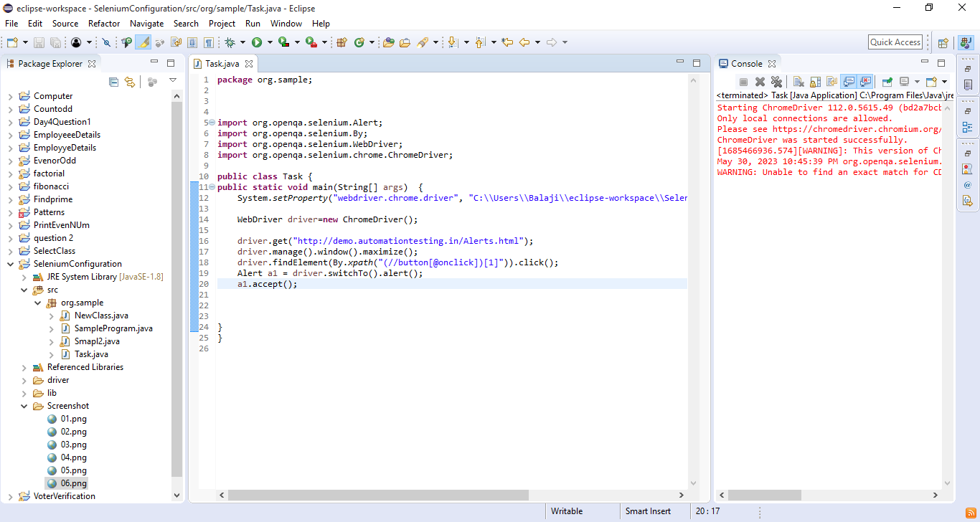

----------

URL : http://demo.automationtesting.in/Alerts.html

NOTE: Click Alert with ok & cancel button and Click button to display an confirm box Perform confirm alert.

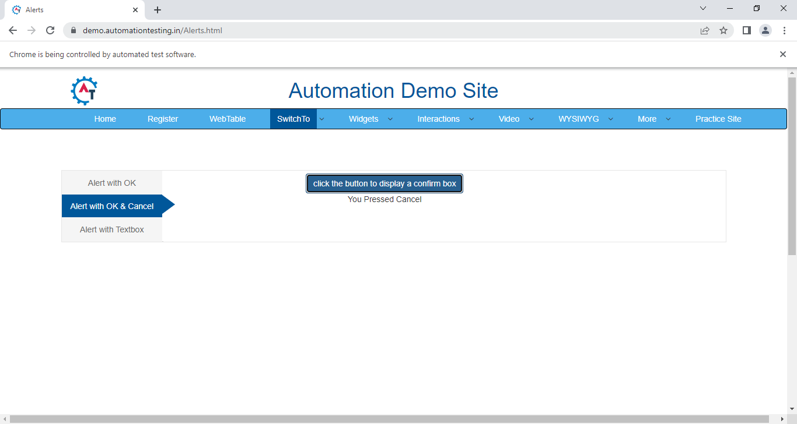

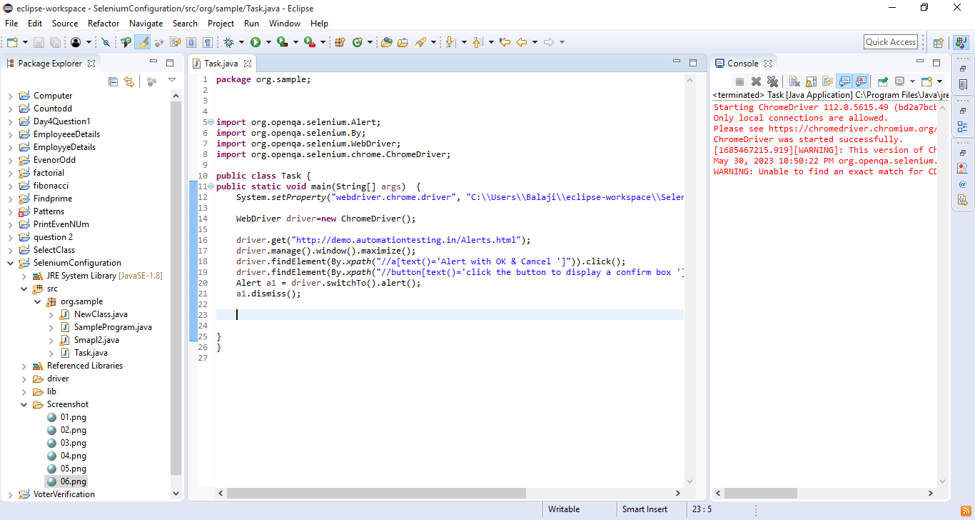

----------

URL : http://demo.automationtesting.in/Alerts.html

NOTE: Click Alert with textBox button and Click button to demonstrate an prompt box Perform prompt alert.

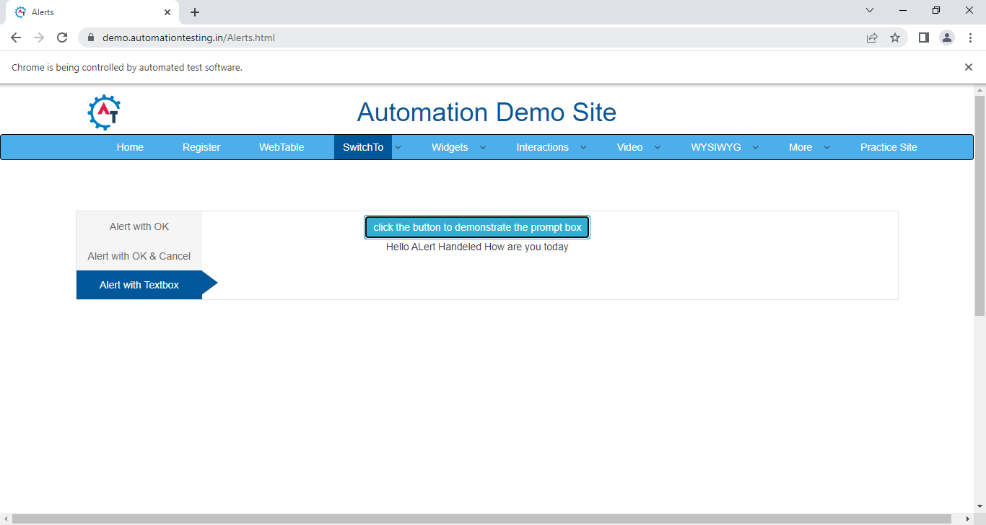

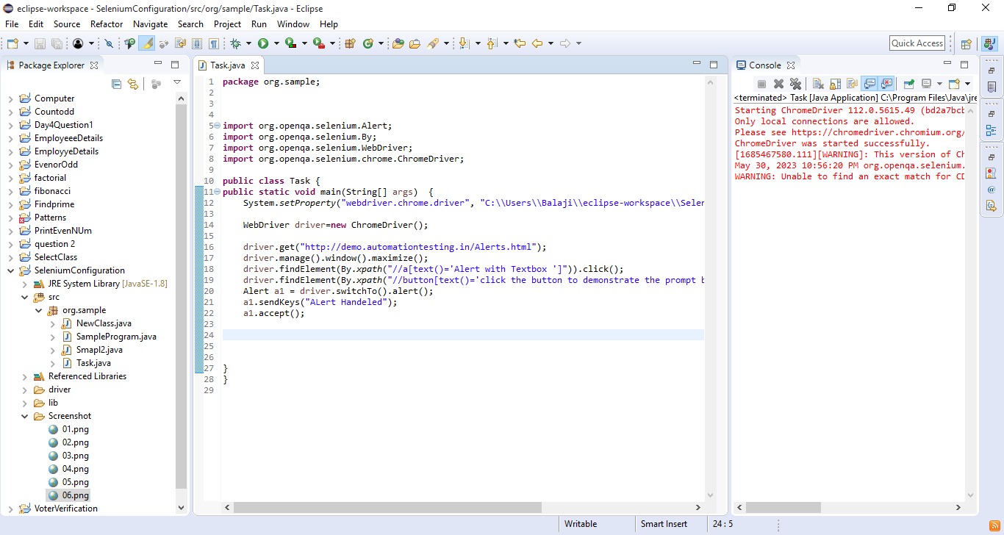

----------

URL : https://netbanking.hdfcbank.com/netbanking/?_ga=2.176378149.1819882415.1533883212-608727520.1532670997

NOTE: Click continue without enter the user id and handle popup.

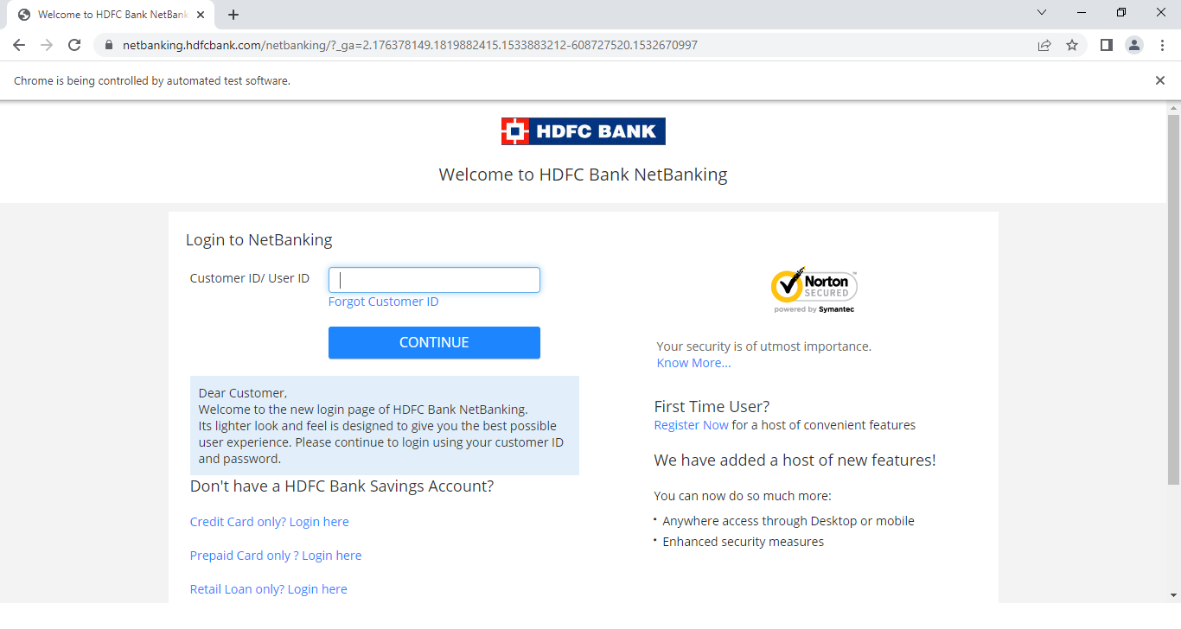

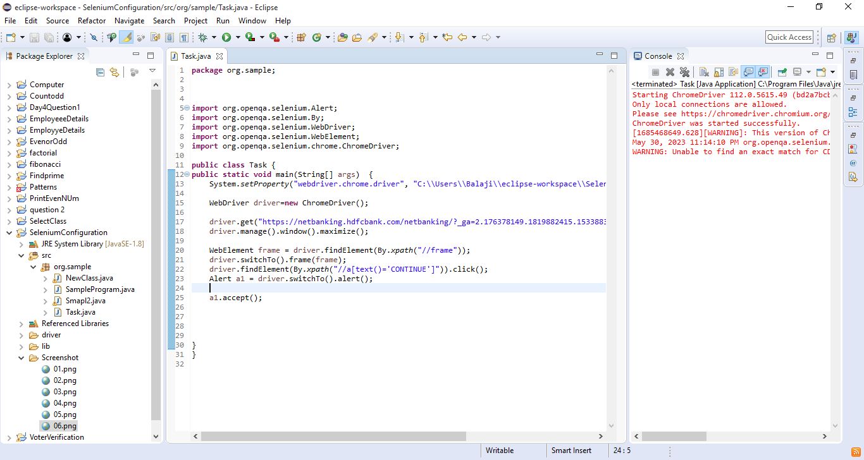

----------

URL : https://netbanking.hdfcbank.com/netbanking/

NOTE: Enter the userId,click continue.

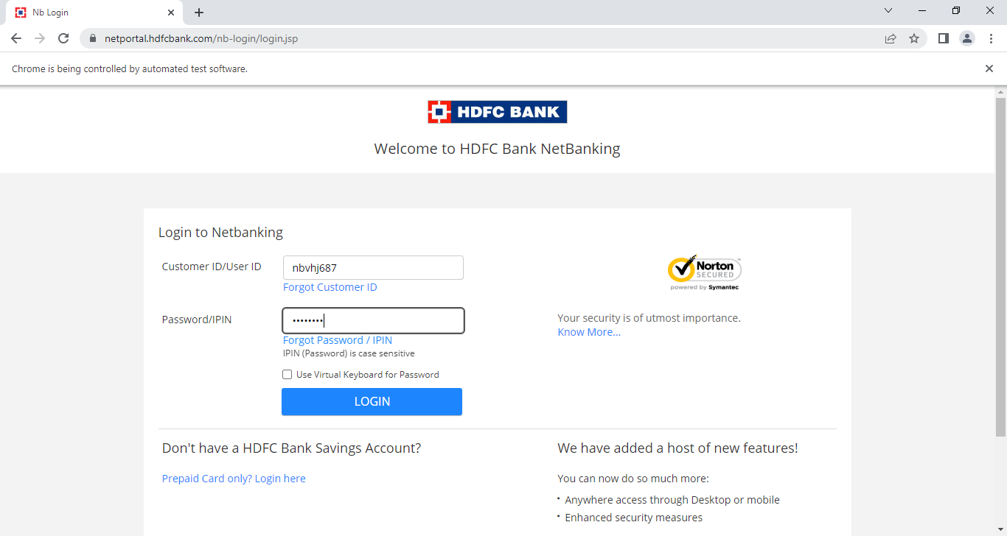

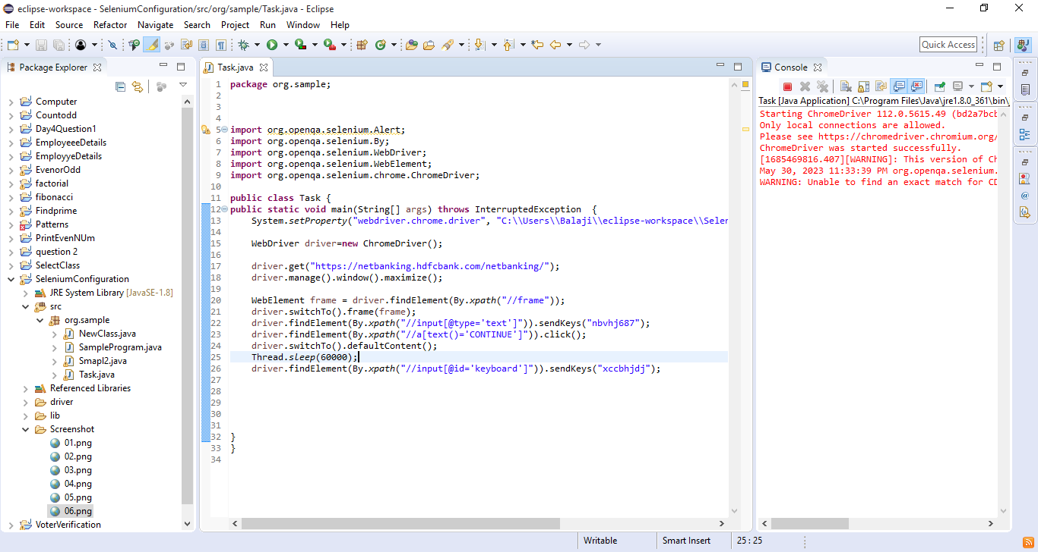

----------

URL : https://retail.onlinesbi.com/retail/login.htm

NOTE: Click Continue To Login and click Login without enter the user id.

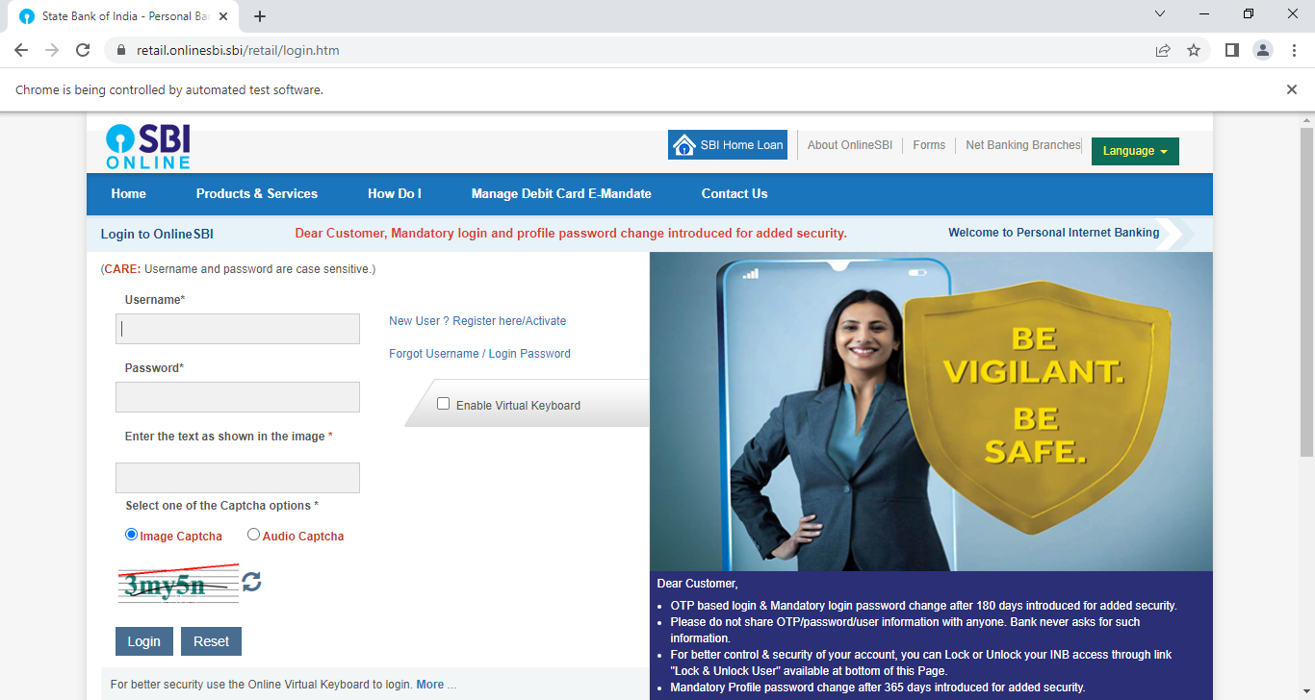

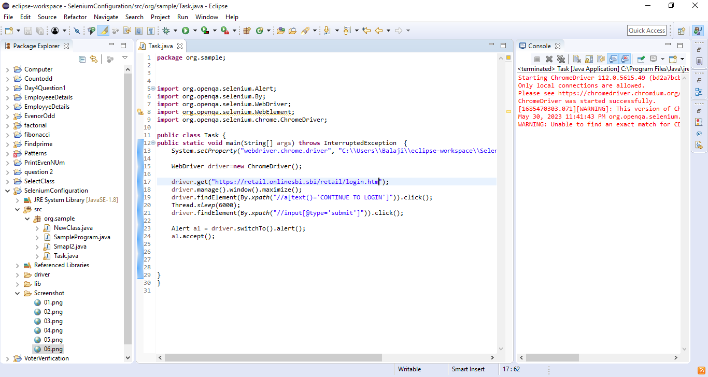

----------

URL : https://infinity.icicibank.com/corp/AuthenticationController?FORMSGROUP_ID__=AuthenticationFG&__START_TRAN_FLAG__=Y&FG_BUTTONS__=LOAD&ACTION.LOAD=Y&AuthenticationFG.LOGIN_FLAG=1&BANK_ID=ICI

NOTE: Enter the userId password.

Click login button

